

March 2018

Dementia Friendly Housing

Report from the Review Group of the Health and Social Care Scrutiny Sub-Committee

Members of the review group

Councillor Michael Borio (Chair)

Councillor Vina Mithani (Vice Chair)

Councillor Niraj Dattani

Councillor Kairul Marikar

Councillor Chris Mote

TABLE OF CONTENTS
Page
- Chair’s Foreword 3
- Background 4
- Context 5
- Dementia friendly housing 10
- Addressing the housing needs of older people
with dementia - examples of good practice 13

- Meeting the housing needs of people with dementia –
Case study: Barnet Council’s Adult Accommodation 15
and Support Services Strategy

- Older people’s housing in Harrow 18

- Steps towards becoming a dementia friendly borough 23

- Conclusions 26

- Recommendations 27

- CHAIR’S FOREWORD
Dementia is the biggest health and care challenge that our generation faces. By 2021, over a million people in the UK will be living with the condition. Globally, the number of people living with dementia will rise from 50 million in 2017 to 152 million by 2050 - an increase of 204per cent. Indeed in Harrow the rate of dementia is projected to increase significantly - by 37per cent - from 2500 residents in 2017 to nearly 4000 residents by 2030. The cost of dementia in the UK is expected to double in the next 25 years - from £26 billion to £55 billion by 2040. Equally, at a time when our NHS is severely stretched, about a quarter of hospital beds are currently occupied by someone living with dementia. Therefore it is vital that we offer more support to those living with dementia and their families. Good quality housing, combined with care and support, can play an important part in this by supporting the independence of those living with dementia and helping to reduce unnecessary hospital admissions.

This scrutiny review, including the final report, seeks to explore how those options can be applied to Harrow to benefit our residents who are affected by dementia. In doing so, it has incorporated the recommendations from the report by the Centre for Public Scrutiny, published in October 2017, on improving the scrutiny function at the London Borough of Harrow, and have looked at a cross-cutting issue that affects the whole borough. We conducted field visits to award winning housing schemes for older people in Waltham Forest and Southwark, visited a dementia support drop in clinic in Harrow and heard from an expert panel of witnesses.

A consistent theme that emerged through the course of our research was the importance of an integrated approach for meeting the needs of older people with dementia in the borough - particularly between housing, adult social care and health. Equally, the importance of partnership working, as highlighted by expert witnesses in the field of dementia care and through best practice, as demonstrated by neighbouring boroughs.

Finally, our research indicated the need for some long-term strategic thinking by Harrow Council in order to ensure that it is able to meet and manage the needs of a growing ageing population with complex needs, utilising current resources and opportunities, against a backdrop of increasing financial pressures and limited resources.

I would like to thank everyone involved in this scrutiny review and in its final report, both the committee members who served on it and especially council staff (including Farah Ikram) who undertook the necessary detailed research, to help us in reaching our final conclusions. I hope that our report will play an important role in contributing to future housing and care & support strategy in Harrow which builds on our existing successful local housing developments for older people and our local support services.

Councillor Michael Borio
Chair, Health and Social Care Scrutiny Sub-committee
- Background
In September 2017, the Council’s Health and Social Care Scrutiny Sub-committee agreed that a review should be undertaken on dementia friendly housing in the borough.

The review topic was chosen due to projections in the number of older people in Harrow with dementia and existing national and local focus on the issue. Nationally, this has included the publication of a Dementia Strategy in 2009, former Prime Minister David Cameron’s Challenge on Dementia, launched in 2012, and the Alzheimer’s Society’s Dementia Friendly Housing Charter, published last March, which contained guidance for housing organisations, corporate bodies and local authorities on improving home environments for people with the condition.

The purpose of this review was to:

- develop a greater understanding of what constitutes ‘dementia friendly’ housing;
- develop a greater understanding of and clarity around whether current housing provision within the borough meets the needs of residents aged 65 and over, diagnosed with dementia, or those that could develop the condition in the future;
- identify measures that the Council could implement to help meet future housing needs and in doing so, identify what overall steps Harrow Council can take towards becoming more dementia-friendly.

The scrutiny review into dementia friendly housing took on board the recommendations put forward in the report by the Centre for Public Scrutiny: Improving the scrutiny function at the London Borough of Harrow, published in October 2017. This review aimed to ‘shine a light’ on issues identified as part of the research process and support strategic thinking around specialist housing and support for older people with dementia.

We took the opportunity to trial a different approach to scrutiny and worked with officers to explore an issue of mutual interest; worked more collaboratively to obtain cross-party consensus and championed the voice and experience of the resident. We also decided to hold a roundtable meeting rather than a challenge panel - not to critique, but to jointly explore the issues.

Methodology

This Scrutiny Review involved desk research, field visits, consultation with service users and a special roundtable, as detailed below:

- Desk research was undertaken to obtain a better understanding of dementia friendly housing.
- Field visits took place to award-winning/highly commended older people’s housing schemes in the London Boroughs of Waltham Forest and Southwark.
- We visited Annie’s Place - a dementia drop-in service for older people diagnosed with dementia and their carers - held weekly at Milmans Resource Centre, Pinner, to obtain a better understanding of what support was being accessed by local people.
- We held a special roundtable meeting on dementia friendly housing, which brought together external experts to share their knowledge and expertise on developing dementia friendly housing, with portfolio holders and senior managers representing Harrow Council’s Housing and Adult Social Care departments.

3. Context
3.1 National context

The National Dementia Strategy: ‘Living Well with Dementia: A National Dementia Strategy’ was published in February 2009. It set out a vision for transforming dementia services with the aim of achieving better awareness of dementia, early diagnosis and high quality treatment at whatever stage of the illness and in whatever setting.

Prime Minister’s Challenge on Dementia 2020
In 2012, former Prime Minister David Cameron, launched his Challenge on Dementia 2020, which set out his programme of action to deliver sustained improvements in health care, create dementia friendly communities, and boost dementia research. A key aim of the challenge is that by 2020 there is an increase in the number of people with dementia being able to live longer in their own homes when it is in their interests to do so.

The Care Act (2014): was introduced in 2014 and sets out a vision for a reformed care and support system. The Act gives local councils responsibility for making sure that people have more control over their care, through effective care and support planning. It places a duty onto local authorities to provide preventative services in a way that meets the needs of people in their borough.

Alzheimer’s Society’s Dementia Friendly Charter

In March 2017, The Alzheimer’s Society published its Dementia Friendly Housing Charter, which seeks to make the housing sector including housing providers, local authorities and sector professionals aware of the challenges of living with dementia so that they can improve home environments for people living with the condition.

Government funding models for supported housing for older people
- In October 2017, the government announced a grant to local authorities to help encourage the supply of wide-ranging supported housing for older people.
- The government is also seeking to improve local planning for supported housing and commissioning across service areas and have set out proposals for a National Statement of Expectation and local level strategic planning to underpin the new funding regime. This will support better, joined-up working across local areas to deliver the best outcomes for vulnerable people, to ensure that public funding is being used effectively and efficiently, and to plan for new supply to meet future demands. These changes will commence from April 2020.

3.2 Regional context

Mayor of London’s Housing Strategy
In September 2017, The Mayor of London published his draft Housing Strategy, which makes specific reference to the provision of supported housing for older people with dementia. The Mayor will invest £75 million through the Care and Supported Specialised Housing Scheme (CASSH) in supported housing for older and disabled Londoners.

Mayor of London’s Draft London Plan

In December 2017, the Mayor of London published his draft London Plan, which is currently out for consultation. Housing policies H14 and H15 recognise the need for specialist housing for older people and makes specific reference to people diagnosed with dementia. Policy H15 Specialist older people’s housing states that “Boroughs should work positively and collaboratively with providers to identify sites which may be suitable for specialist older persons housing, taking account of:
  - local and strategic housing needs information and indicative benchmarks for specialist older people’s housing;
  - the need for sites to be well-connected in terms of contributing to an inclusive neighbourhood, access to social infrastructure, health care and public transport facilities;
  - the increasing need for accommodation suitable for people with dementia.
The Draft London Plan includes benchmarks for specialist older people’s housing across all London boroughs. Table 1 provides details of benchmarks set for Harrow and neighbouring boroughs:
Table 1
Borough | Annual benchmark for specialist older Person’s Housing Units
Barnet | 275
Brent | 230
Ealing | 200
Harrow | 165
Hillingdon | 180
Source: Mayor’s Draft London Plan, Housing Policy H15: specialist Older People’s Housing, December, 2017

3.3 Local context:

Harrow’s ageing population

- Harrow has an ageing population, with an estimated 15 per cent (38,600) of people aged 65 and over.
- The number of people aged 65 years and over in Harrow is projected to increase by 25 per cent over the next 12 years (see table 2). According to analysis of population projections undertaken by the GLA, the majority of Harrow’s older population aged 65 plus are located in the north and north-western parts of the borough, with a higher proportion based in Stanmore and Canons wards (see figure1).

Table 2 Population projections for people living in Harrow aged 65 and over
 | 2017 | 2020 | 2025 | 2030
People aged 65-69 | 11,000 | 11,500 | 13,000 | 14,200
People aged 70-74 | 9,300 | 10,200 | 10,600 | 12,100
People aged 75-79 | 7,100 | 7,400 | 9,100 | 9,600
People aged 80-84 | 5,700 | 6,000 | 6,300 | 7,800
People aged 85-89 | 3,500 | 3,800 | 4,400 | 4,700
People aged 90 and over | 2,000 | 2,300 | 2,900 | 3,600
Total population 65 and over | 38,600 | 41,200 | 46,300 | 52,000
Source: Projecting Older People Population Information (projections based ONS sub-national population projections, May 2016)

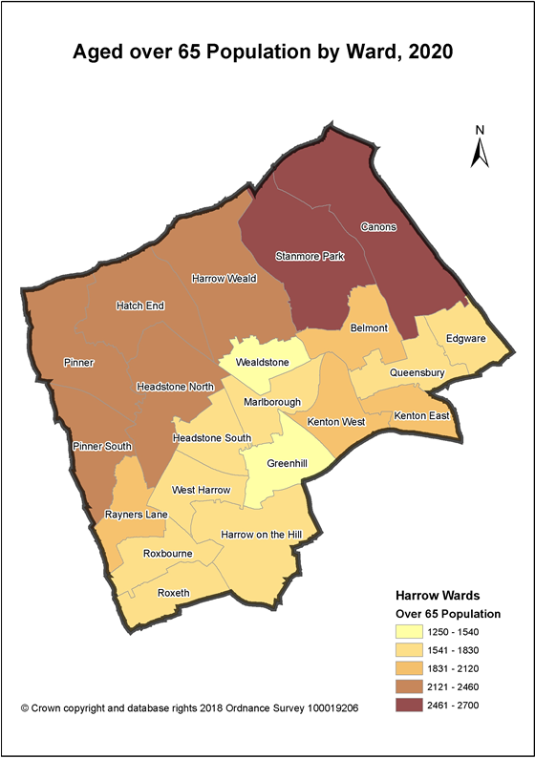
Figure 1: Population projections for the number older people living in Harrow aged 65 and over by ward: 2020
GLA population projections for the number of older people in Harrow by Ward: 2012-2020 by ward, based ONS 2012 subnational population projections (SNPP). Taken from Harrow JSNA Refresh Update: focus on dementia, 2013/2014

Older People with dementia

- There are an estimated 2,500 people aged 65 plus in Harrow with dementia, of which 1586 are recorded as having a formal diagnosis.
- Patient diagnosis rates in Harrow have significantly improved since 2009, where the estimated diagnosis rate for dementia stood at 32 per cent. In 2014, the restructured community based Memory Assessment Service, based in the Bentley Centre, Wealdstone, was launched to provide improved early diagnosis and treatment for dementia. The latest data shows that the diagnosis rate has doubled to just over 63 per cent (see table 3).
- Diagnoses rates in Harrow are lower in comparison with neighbouring boroughs. Table 2 shows that in Brent, the estimated number of people with dementia is slightly lower than Harrow, but the number of people recorded to have a diagnosis is 10 per cent higher, at just over 77 per cent.

Table 3 Estimated and recorded numbers of Dementia patients aged 65 and over in Harrow and neighbouring boroughs, 31 December 2017.

Borough | Estimated | Recorded | Diagnosis rate%
Barnet | 3,774 | 2,785 | 73.8
Brent | 2,409 | 1860 | 77.2
Ealing | 2,869 | 2203 | 76.8
Harrow | 2,506 | 1,586 | 63.3
Hillingdon | 2,708 | 1838 | 67.9
Source: Quality Outcome Framework, NHS Digital, December 2017

- Dementia rates in Harrow are projected to increase significantly over the next twelve years by an estimated 37 per cent, from 2500 to just under 4000. Dementia levels are projected to be higher among people aged 85 and over. The North West London Sustainability and Transformation Plan 2017, states that in Harrow “there will be increased NHS & social care costs due to the ageing population and increasing dementia prevalence”.

- In Harrow, approximately 67 per cent of the population aged 65 and over are White. The largest ethnic minority group is Asian/ Asian British (27 per cent of the 65 plus population). Harrow will see an increase in the ethnic diversity of its older population. The number of people with dementia from Black and Minority Ethnic groups is also predicted to rise. This is due to the high incidence of high blood pressure, diabetes, stroke and heart disease within these communities, which are risk factors for dementia. These communities also tend to access services later, which can have a negative impact on families as they may have struggled for longer without support.

4. Dementia friendly housing

4.1 This review considered guidance contained in the Alzheimer’s Society’s Dementia Friendly Charter, published in March 2017. The Charter aims to help housing professionals better understand dementia and how housing, its design and supporting services can help support people affected by the condition in their homes. The Charter states that “every individual and organisation working in the housing sector can make a difference to the lives of people living with dementia. In working towards this, everything should be considered from the viewpoint of someone with dementia and how ‘people’, ‘places’ and ‘processes’ can support them”.
In all
- People: includes housing management, staff, landlords, and people undertaking adaptations and maintenance to homes.
- Places: refers to the interior and exterior buildings and dementia-friendly design
- Processes: include residential policies management, planning and other housing related services.

- The Charter acknowledges that older people with dementia prefer to live independently in their own homes. The most suitable alternative options for older people with dementia to be able to live independently include specialist older people’s accommodation such as Extra Care, or sheltered accommodation with care and support on site.

- Extra Care schemes promote and support Independent Living and Lifetime Neighbourhoods. Benefits include enabling residents to live in a home of their own for longer and for couples to stay together. A report from the International Longevity Centre found that those living in Extra Care were less likely to be hospitalised, experienced a lower number of falls, and better health outcomes. While a report from the University of Kent Personal Social Services Research Unit study indicated that “living in an Extra Care scheme improves mortality and survival rates when compared to more traditional residential care settings”.

4.2 What do we mean by the term ‘Dementia friendly environments’?

The Health Sub-committee hosted a special meeting on dementia friendly housing and heard evidence from expert witness Jo Crossland, Head of Dementia Care, Avery Healthcare. Jo Crossland has worked as a Registered Nurse for 28 years within the NHS and independent healthcare sector. She has previously supported people living with dementia in a variety of care settings and currently oversees dementia care support at Birchwood Grange nursing home, based in Kenton. She has also advised a number of local authorities and housing associations on dementia friendly housing environments and design. Based on her extensive experience, Jo provided the following guidance, which is summarised as follows:

- Jo Crossland suggested that housing providers and carers needed to take into consideration the following issues that are faced by people diagnosed with dementia:

- Problems identifying colour or tones
- Difficulties with coordination
- Problems orientating or finding things within the environment
- Losing track of time
- Difficulty with reading, writing and numbers
- Problems recognising objects and places

A dementia friendly environment should be:
- Homely
- Enabling
- Adaptable
- Flexible
- Comfortable
- Safe (emotionally and physically)
- Able to meet the changing needs of the people living there
- Providing person centred care
- An environment which is easy to navigate without too many signs and difficult layouts.
- A community which is patient with people who need to go a bit slower, to have more time to work things out
- A community that cares for people with dementia, by providing support services and excellent care.
4.3 Assistive Technology

- Assistive technology can help people to remain in their own homes with support and can also be used in a care home environment. Assistive technology is ‘any device or system that allows an individual to perform a task that they would otherwise be unable to do or increase the ease and safety with which the task can be performed’. Products range from simple ‘low-tech’ items such as basic mobility devices, calendar clocks to ‘high tech’ electronic and information and communication technology systems, such as telecare sensors, detectors and electronic location devices that automatically send signals via a base unit connected to a community alarm or monitoring service.

- Assistive technology can support people with dementia to live independently in their homes for longer and can potentially enhance their quality of life. However, the opinion among experts is that assistive technology should be personalised to the individual. This position was supported by our expert witness, Jo Crossland, who also advised that a ‘blanket approach’ to purchasing assisted technology equipment for people with dementia is a high-risk strategy.

- With reference to assessing the needs of an individual with dementia, in Jo’s opinion, this required a degree of skill in being able to ask the right questions and identify the most appropriate interventions/ equipment, which can be acquired through the right training. Often, it can be the case that a common, practical solution might prove more appropriate; particularly in cases where the person is in the early stages of dementia. Simple, everyday household items such as prompts, post-it notes, speaking clocks and alarms, white boards and memory joggers can prove just as effective.

Good practical examples of equipment currently on the market:
- Cooker sensors
- Water tap sensors
- Sensor mats

- While assistive technology can offer people greater independence, the opinion among dementia care experts is that there are products on the market including CCTV, baby monitors, etc. that could compromise a person’s privacy, or exacerbate a person’s condition. In conclusion, the general consensus of opinion among experts is that assistive technology should be viewed as a way of supporting someone to manage their condition and not a substitute for domiciliary care..

4.4 Dementia friendly design

- Design principles have an important role to play in making an environment easy to navigate. However, the needs of the individual should also be taken into account when planning and designing extra care housing developments. Use of colour schemes and signage may prove useful for some, but not for those that may suffer from colour blindness, or are unable to read signs.

Dementia friendly design should incorporate:

- Good lighting
- Space
- Avoid narrow corridors
- Communal space for people to interact and socialise
- Easy to navigate
- Intuitive (a dining room should be situated where one would expect it to be located).

- Housing environments should be designed to adapt to the changing needs of a person with dementia, which would enable them to stay at home for longer. Accommodation can be designed to provide flexible living space, which can be adapted as the person’s condition progresses. For example, transparent doors on kitchen cupboards and drawers can help the person see where kitchen utensils are kept.

- Older people with dementia and other complex needs want to lead as normal a life as possible and to be able to live independently in their own homes. Therefore, the location of a supported living/Extra Care development should ideally be in the heart of the community, close to local shops and easily accessible. What also makes for a good dementia friendly environment is one that can house people with a mixture of conditions and needs, run by care staff that understand the needs of people with dementia.

5. Addressing the housing needs of older people with dementia-examples of good practice

As part of the evidence gathering process, members and policy officers visited award winning, accredited and highly commended Extra Care Schemes and sheltered accommodation developments in Waltham Forest and Southwark, to gain a better understanding of what makes for a conducive environment for older people with a range of needs, including dementia. The following pages provide a summary of key findings from our visits.

5.1 Waltham Forest Housing Association (WFHA):
- Waltham Forest Housing Association is a small, locally-based housing association, based in Essex, predominantly providing sheltered housing. As many as 14 per cent of their tenants, live with dementia. WFHA was appointed as a dementia champion by the Alzheimer’s Society and set up the borough’s local Dementia Action Alliance.

- Two sheltered accommodation developments, based in the heart of Waltham Forest town centre, were visited on 13th November 2017.Electric House and Kevan Court are sheltered accommodation schemes that also offer Extra Care support and provide independent living for a mixture of residents, including working, non-working, residents with disabilities and low-level dementia. Both schemes comprise a total of 51 one and two bedroom flats, with a communal space on each floor.

- At the time of the visit, 20 per cent of residents with low-level dementia were residing at both Electric House and Kevan Court. Weekly rent ranged from £508 to £652, with a care package.

- Both housing schemes provide tenants with access to community alarms, pendants and a door entry system provided by Tunstall and linked to a Newham Network control centre. All of the above services were included within the service charge.

- Total annual management cost (including 24 hour call out, First Response and mobile warden): £150,000 per annum. 60 per cent of the annual costs are covered through the Supporting People fund.

- WFHA developed a dementia-friendly specification as part of its programme of maintenance works on both properties. It worked in partnership with Dulux Paints and dementia housing design experts from the Alzheimer’s Society. Contrasting colour schemes were chosen for use in communal hallways and on each level and specially designed signage was installed to help residents with dementia navigate their way easily around the building and to their accommodation. The costs of these works were included as part of the annual building maintenance programme.
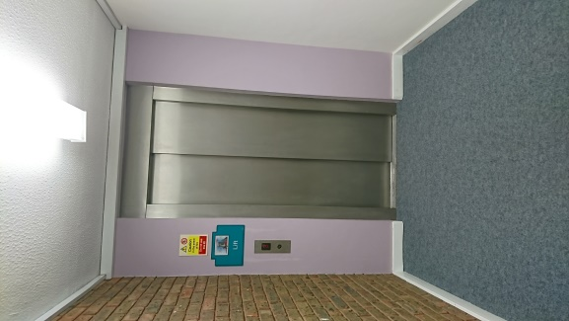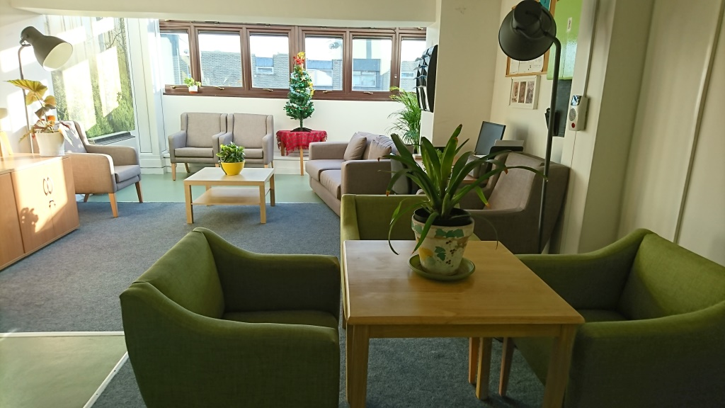
Kevan House - lift and hallway Electric House, communal living room
WFHA were responsible for forming the local Dementia Action Alliance and arranged social activities for tenants and awareness raising sessions for residents to help them better understand and support those with dementia.

5.2 Windmill Court Extra Care Housing, Chingford, Essex

- This Extra Care housing development was built in 2015 and won the HAPPI (Housing our Ageing Population Panel for Innovation) Housing Design Awards in 2016. The scheme is owned by Waltham Forest Council and managed by Centra Housing Association.

- The scheme comprises 44 extra care one and two bedroom apartments, providing independent living space for residents aged 24-60 and over, with a range of conditions, including dementia. At the time of the visit, nine residents had low to medium level dementia and were supported through an individual care package. Weekly rent was charged at £763 including service charge, which covers the cost of telecare (pendant and intercom in apartments).
- The scheme included a dementia day centre and a range of social activities for residents, including trips out and visits from local voluntary organisations. All staff on site had received dementia training and residents were also able to access floating support (help with managing finances and filling out forms etc.).
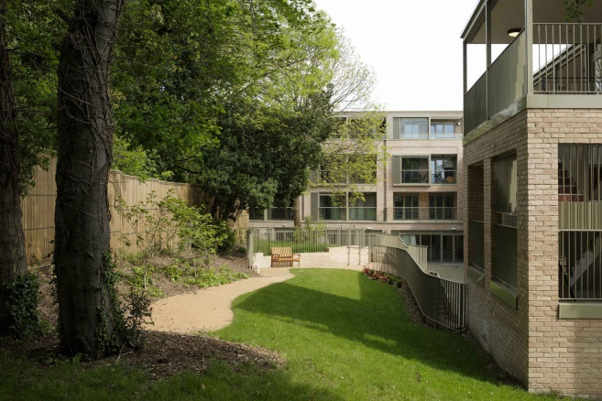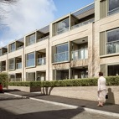
Windmill Court Extra Care Scheme: Pictures courtesy of Tim Crocker

5.3 Tayo Situ House, Extra Care Scheme, London Borough of Southwark
Tayo Situ House in the borough of Southwark, forms part of the Council’s pledge to become an age-friendly borough. Its housing strategy includes building 1,500 new council homes by 2018. A new Day Centre is being built next door to the scheme and due for completion later this year. The development comprises 42 apartments, built to accreditation standards set by Stirling University’s Centre for Dementia Care. The scheme was visited in November 2017, by Health Sub-Committee Chair, Councillor Michael Borio.

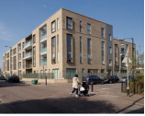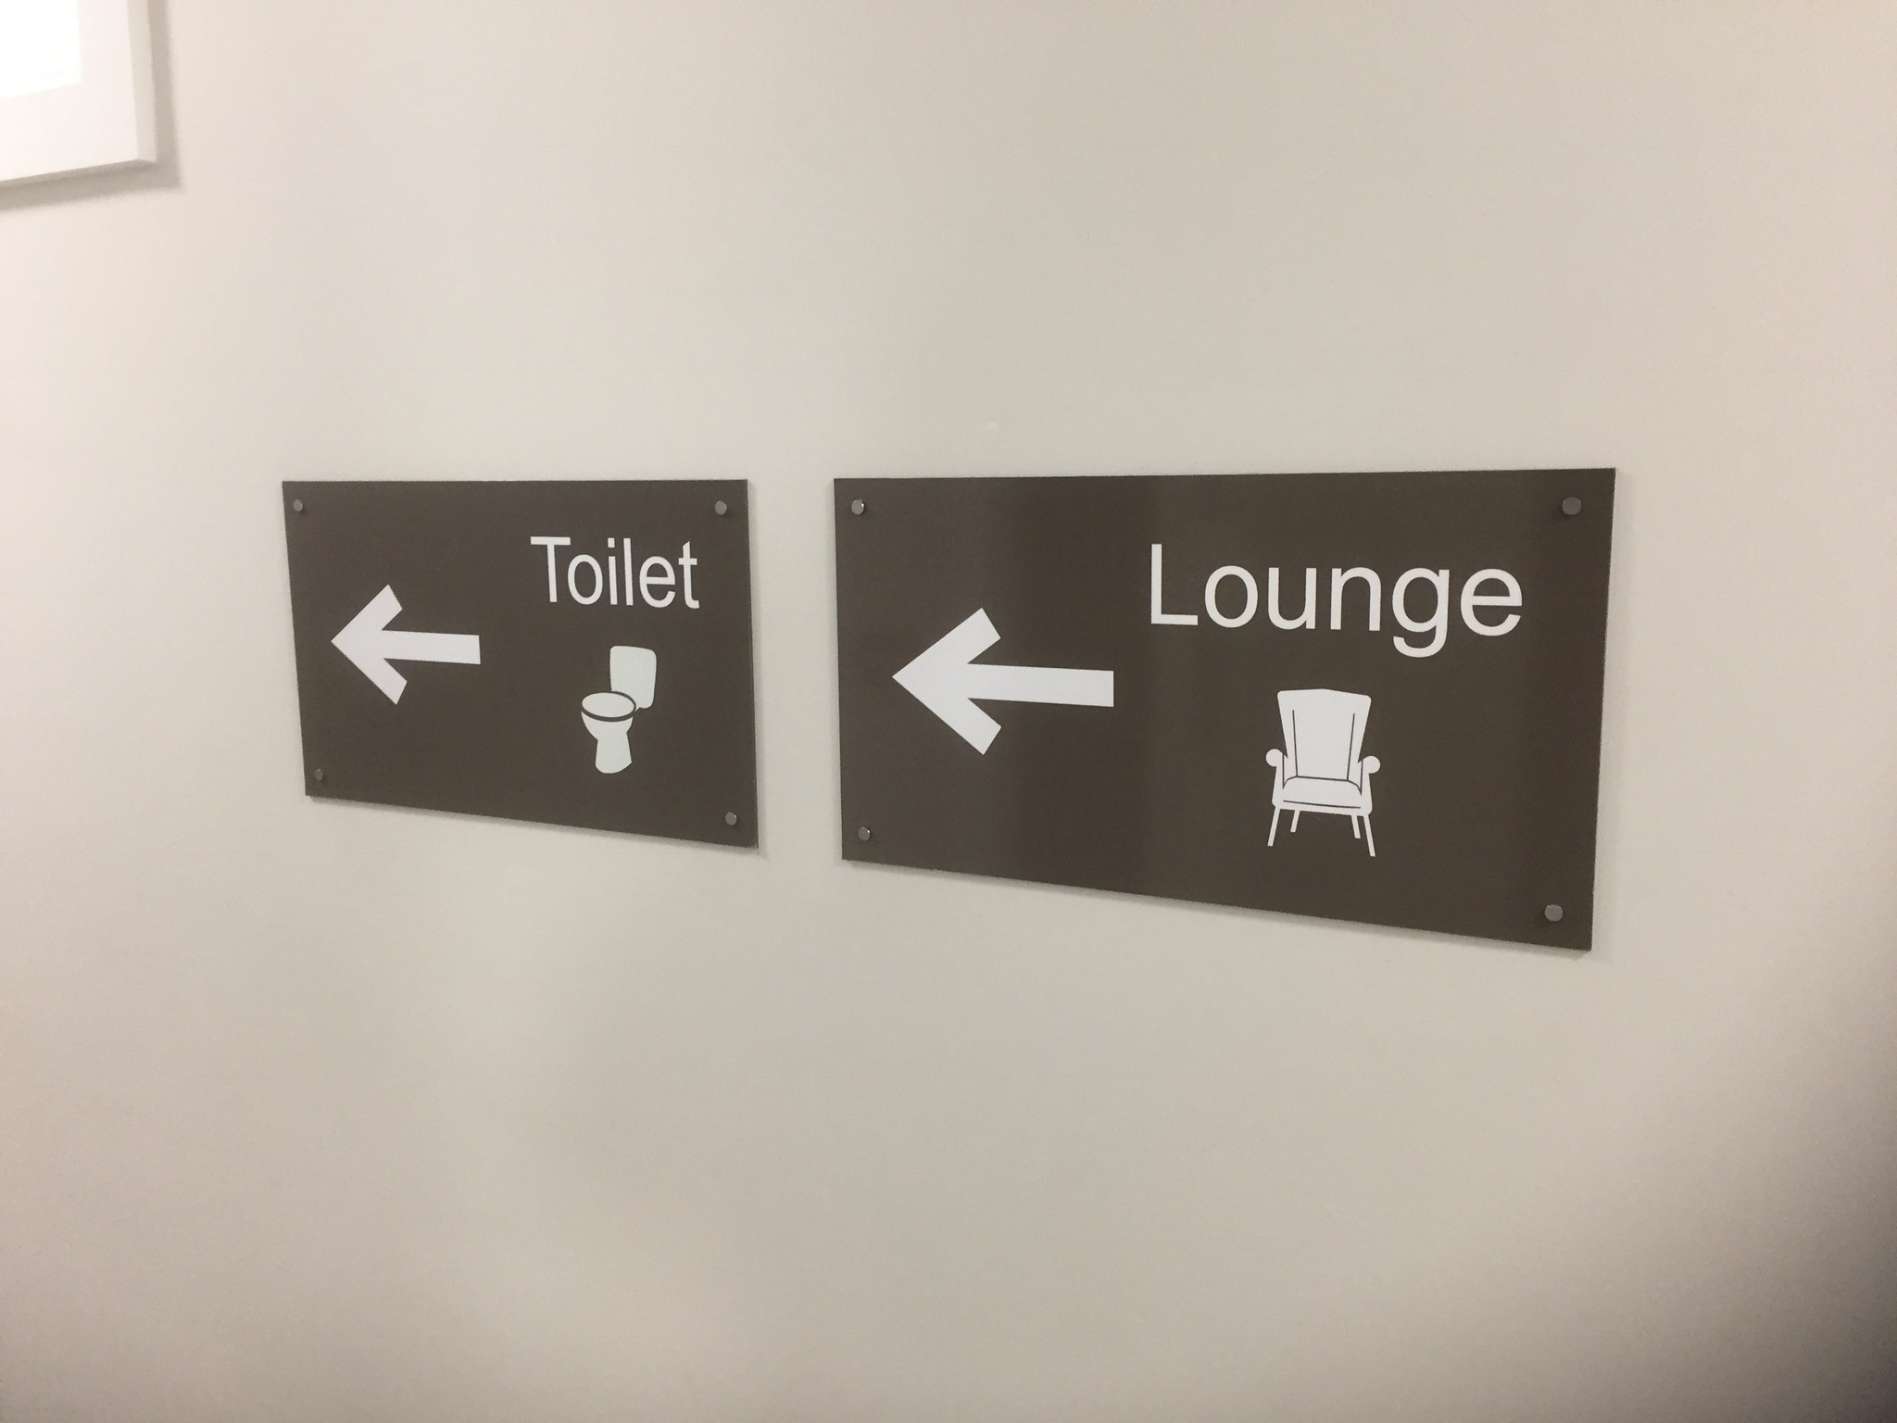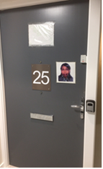

Tayo Situ House: external view and examples of visual signage and prompts to support residents with dementia

At the time of the visit, Tayo Situ House was fully occupied, apart from one flat that was being refurbished. There was an impressive use of descriptive visual signage throughout the development to assist residents in finding key areas such as the lounge, garden, toilets etc. One resident with dementia even had a picture of her face outside her front door to help her find her way back to her flat. There were also a range of regular social activities to help new residents settle in and providing residents an opportunity to interact with each other.

6. Meeting the housing needs of people with dementia - Case study: Barnet Council’s Adult Accommodation and Support Services Strategy

6.1 As part of the special roundtable on dementia friendly housing, Susanne Tomlin - Lead Commissioner, Learning Disabilities and Physical & Sensory Impairment, and Catherine Searle, Interim Assistant Director of Joint Commissioning, NHS Barnet CCG & Barnet Council, were invited as expert witnesses to share their expertise and learning in the development of its 2016 Adult Accommodation and Support Services Strategy.

- The key aim of the strategy was to develop a new model of accommodation and support needed in the borough to help people remain independent.

- Funding pressures on the adult social care budget and the fact that a large proportion of the budget was being used to pay for residential care were key drivers in the decision to develop the strategy. Barnet council also acknowledged that its sheltered housing stock was not being utilised effectively. Some schemes were not fit for purpose and becoming harder to let.

- In 2013, Barnet Council undertook a detailed and comprehensive needs analysis to help forecast future demand for care and supported accommodation. The outcomes of the assessment resulted in cross-party agreement that something needed to be done to address the gap in housing provision. This led to a commitment by the Council to develop a wider housing strategy, to include Extra Care housing and support, which would be delivered in partnership with its Arms Length Management Organisations (ALMOs) - Barnet Homes and the Barnet Group. These organisations provide housing services, manage and maintain the Council’s housing stock and also provide care support services. Floating and care support are integrated, which makes for better provision and management of care. Barnet has a good relationship with its ALMOs. Staff within the Barnet Group have extensive expertise in adult social care and a good grasp of care needs.

- Fundamental to the strategy are the themes of prevention and early intervention, to help manage costs and help people remain in their homes for as long as possible.

- The strategy has been successful in parts and is due to be refreshed later this year. Revised plans will take into account recent government policy on affordable housing and extra funding for supported housing.

- With reference to long-term strategic planning for care, Barnet Council undertook some scenario-setting and financial modelling to assess what the risks and outcomes would be if the decision was taken not to build any more Extra Care schemes. Forecasting and projections took into account population estimates, using a combination of GLA population projection figures and data from Projecting Older People Population Information (POPPI) and Projecting Adult Needs and Service Information (PANSI).

- The outcomes of the exercise indicated that the costs to support a relatively small cohort of people with high care needs within a residential care setting would escalate significantly. This led to an acknowledgement that a future strategy would need to account for the fact that that the provision of care services is an expensive business, but that the Council needed to direct its resources and invest in the short term in order to achieve maximum outputs/cost efficiencies and positive outcomes in the longer-term.

- It is also taking a long-term strategic approach, which takes into account the concept of cost avoidance v cashable savings. Investing finance and resources in Extra Care/ supported housing and care is likely to cost more in the short-term but that the outcomes from the financial modelling exercise showed that it would lead to cost savings over time. This requires close monitoring of the situation over a period of time to be able to evidence whether the strategy is delivering services and utilising resources effectively.

6.2 Development of Extra Care Housing in Barnet
- Barnet acknowledged that outcomes are poor for people who are moved to different environments as their needs become more complex. As stated previously, people want to stay as long as possible in their homes and to be able to be supported to live independently with their condition as it progresses.

- The development of Extra Care housing was incorporated within a wider regeneration programme and corporate strategy for the borough. Adult Social Care, housing and health were brought together to develop the supported accommodation strategy.

- Recent Extra Care developments, including Moreton Close, comprise 50-55 units, offering rental and shared ownership options, providing accommodation to a mix of residents, requiring varying levels of care and support. Initial plans for the development of Extra Care accommodation at Moreton Close commenced in 2013, and the development is due for completion later in 2018. The average length of time taken from initial concept to completion is an estimated eighteen months. The Council ensured that robust project management procedures were put in place to ensure that the project is delivered to specification and within agreed timescales.

- During the planning phase, Barnet took into consideration a number of factors to help determine the maximum number of units that would help deliver optimum outputs and best value. Calculations took into account capital outlay, estimated running costs (including staff and management) and care costs. The Council also took the decision to build all supported /Extra Care accommodation on Housing Revenue Account (HRA) land, which enabled the council to generate extra housing revenue.

- Extra Care supported housing developments are located in the heart of the community, close to shops, community and support organisations, transport and other amenities. Service Level Agreements for Extra Care and supported housing include the provision of outreach activities and a café. Residents also have access to a range of GPs and other healthcare services.

- Barnet Council facilitated stronger partnership working with its local Clinical Commissioning Group (CCG) and Voluntary and Community Sector (VCS), through the provision of dedicated resources to manage stakeholder engagement, with service users, partnership boards and other organisations that have been involved with providing input to the design and development of Moreton Close and other Extra Care developments.

- In 2015, the Council developed a Dementia Manifesto, in partnership with Barnet CCG, local VCS and service users. The manifesto aims to support and signpost people with dementia to various services and provides a cost effective approach to dementia care in the community. Services include: lunch clubs, information and advice services and the provision of community social activities. While many local authorities have reduced funding to voluntary and community organisations, Barnet Council took the decision to continue funding its local VCS and help support the development of a strong partnership network of organisations. Members were keen to ascertain whether the provision of funding for the VCS has led to a reduction in referrals. Barnet Council’s commissioners explained that it was too early to assess the outcome of this decision. The Council is currently focusing its efforts on reviewing dementia services provision in the borough.

- Future plans: Barnet is now looking to develop/expand its Shelter Plus schemes, which provide a bridge between sheltered and Extra Care, offering on site care staff support.
7. Older people’s housing in Harrow

7.1 Housing tenure:

- Data from the 2011 Census showed that in Harrow, the majority of older people (over 81 per cent) aged 65 owned their own homes, with a small minority (between 6-9 per cent) living in council rented, or other social rented ( 3-5 per cent).
- A detailed and comprehensive review of Older People’s Housing in Harrow was last carried out thirteen years ago in 2005. The review concluded that:
- Harrow did not have a massive overabundance of sheltered housing. Taking rented and leasehold units together, the total supply of 1,921 units represented 132.8 units per thousand of those 75 years and above, compared with the national average of 136.2.
- The provision of other forms of specialised accommodation in Harrow in Registered Care Homes, Homes with Nursing Care and those providing specialised accommodation for older people experiencing mental health/cognitive ability issues was relatively limited. In 2005, the ratio of registered places in residential care to the population over 75 years of age was 28.5 per thousand, and that for nursing home places was 37.1 per thousand.
- Going forward, the review also proposed a future target of 87 units of accommodation, for people aged 75 plus with dementia.

- The review made several recommendations to help address the shortage of appropriate accommodation and housing options for Harrow’s older residents:

- Recommendation 19: The Authority should establish a group of officers, colleagues from health and older people with experience of coping with dementia, to explore the available models of housing for people with dementia, with a view to initiating a pilot scheme in Harrow.
- Recommendation 20: With colleagues in health the Authority should explore how accommodation may be made available, on both a short-term and longer-term basis, to older people with mental health problems to provide an alternative to hospital or nursing home care.

7.2 Local Housing Strategies
A review of various housing related strategies published by the Council since the older People’s Housing review was undertaken, acknowledges that there was still a need for a broader range of housing options for appropriate housing for older people. Yet, none of the policies specify the development of specialist accommodation for older people with dementia, or refer to the recommendations contained in the Older People’s Housing Review from 2005.

- Harrow Council’s Supported Accommodation Strategy, published in July 2010, highlighted the need for changes in the range of supported housing available to a number of client groups in Harrow over the medium to long term. This included the need for a broader range of supported housing options, including a range of tenure types and levels of care and support for older people, and those with learning disabilities, physical disabilities and mental health needs.
- Harrow Council’s Housing Strategy 2013-2018 (p7) states that:
“There is a need for supported housing to meet the needs of vulnerable people, including a range of sheltered/ Extra Care housing (as an alternative to residential care and to meet the needs of people with dementia) and supported accommodation to meet the needs of people with learning disabilities and mental health needs. This will be predominantly in the social housing sector”.
- Build a Better Harrow Regeneration Programme: The borough’s Regeneration Strategy is a wide-ranging and Council-wide programme for the future development of Harrow. Over the course of the Regeneration Programme, it is estimated that around £1.75bn will be invested in Harrow and Wealdstone town centres, delivering 5,500 new Homes. Yet there is no specific mention of housing proposals to accommodate the needs of a growing ageing population the borough.

7.3 Specialist housing provision for older people with dementia in Harrow

- Information gathered from the Elderly Accommodation Council website, which contains details of housing options for older people by borough, indicates that there are roughly 122 housing schemes for older people in Harrow. Details are as follows:
- Private retirement homes: 53
- Extra Care homes: 3 (Watkins House owned by Harrow Council), Ewart House, Paxfold House, (sheltered accommodation that is Extra Care ready). These schemes House are owned by Harrow Churches Housing Association.
- Care homes: 23
- Care homes with nursing: 12
- Sheltered accommodation 17 (owned by Harrow Council) 14 Housing Association owned sheltered housing schemes (Sheltered Housing is not usually suitable for people with dementia.
- Watkins House is a council-owned Extra Care scheme based in the south of the borough, in Greenhill Ward. The scheme currently comprises 43 bedsit units. The scheme is technically classed as a sheltered plus development, as care and housing related support is provided on site. In 2017, Watkins House was rated ‘good’ by the Quality Care Commission. However, the scheme is now considered to be outdated, especially in the context of the bed-sit accommodation for the current group of residents.

- In October 2016, Cabinet agreed proposals put forward by the Council to re-develop Watkins House to provide a minimum of 52 one bedroom flats designed to HAPPI standards. In addition, there is a piece of land owned by the Council that is adjacent to Watkins House and was formerly leased to the Harrow & Brent Sea Cadets. The Council regained possession of the land and intends to include this land as part of the re-development of Watkins House. The scheme and adjacent land can sustain approximately 70 plus homes, comprising a mixture of Extra Care and sheltered accommodation, which can be adapted over time to meet changing needs of residents. The redevelopment of the scheme is expected to be completed in 2020/21.

- Members visited the scheme in November 2017, to view the current design and layout prior to its re-development. We were given the opportunity to visit a number of bed-sits that were currently vacant and spoke with the scheme manager and residents. We concluded that the scheme was in need of modernisation, but that this presented the Council with an opportunity to take on board best practice and guidance in the development of a mixed use scheme, which could provide a suitable alternative to institutional care for people with dementia, as well as those with other complex needs. At the time of our visit, we were advised that Watkins House was no longer accepting new residents and existing tenants were being re-housed at other schemes in and around the borough.

- The Council currently has a contract with Harrow Churches Housing Association to provide care and support at Ewart House Extra Care scheme, based in Greenhill Ward and Paxfold House Extra care Scheme, which is located in Stanmore. Ewart House is an award winning scheme comprising 47 self-contained flats, which are fully occupied. Harrow Council currently funds 24/7 care support services for residents living in Ewart House. The total value of the previous contract 2010-2015 was in the region of £500k. In 2015, Paxfold House was re-developed to Extra Care standards, with funding from the Mayor’s Care and Support Specialised Housing Fund to provide 22 one bedroom homes for older people with care needs.

- At the time of the research, it was not possible to conduct an accurate and comprehensive audit of the proportion of people with dementia residing in various types of supported accommodation (private/ registered provider owned accommodation) within the borough.

- Performance data for Harrow Council 2016/2017 indicated that the Council funded care and support services to a total of 246 people, with physical, sensory, mental health, cognitive and memory conditions in non – council owned residential and nursing homes located in Harrow and in other boroughs. An estimated 14 per cent (36) of people with cognitive and memory issues were supported to live in residential and nursing homes within Harrow and in other boroughs. This figure is likely to be an underestimate as the data categories only capture details of the person’s primary condition and not any co-morbidities, including dementia. A total of 18 people with memory and cognition issues were living in residential and nursing homes in other boroughs.

Given future projections for the number of people diagnosed with dementia in the borough, the demand for Extra Care housing and residential/nursing homes is likely to increase.

Recommendation 1
Harrow Council undertakes a detailed and comprehensive needs analysis of demand for accommodation and support for older people in the borough and those diagnosed with dementia and other complex conditions.

- During the special roundtable meeting on dementia friendly housing, held on 31st January, 2018, we took the opportunity to discuss housing options for those eligible for support from Adult Social Care budgets. Outcomes of the question and answer sessions are summarised under the following themes:

Provision of dementia friendly housing in the borough:

- We were informed by the Council’s Director of Adult Social Care, Visva Sathasivam, that other neighbouring boroughs had significantly more Extra Care housing units in comparison to Harrow and acknowledged that additional Extra Care housing was required and other solutions also needed to be considered. Visva Sathasivam provided details of a new project to develop an intermediate care and wellbeing scheme on an existing site in Pinner Road, Headstone South Ward, which will be delivered in conjunction with Westmoreland Housing Association. The scheme is aimed at people who are discharged from hospital, and is a proactive “step down” alternative to residential care. The scheme will enable a person to recuperate for a period of 4-6 weeks before returning to their own homes. The scheme comprises 21 flats, of which five will be fully adapted through the use of Disabled Facilities Grant funding and will be equipped with high-tech telecare systems. Assessments will be undertaken to determine what support the person needs and/or adaptations required to make their home environment safe for them to live in, once they have left the facility. The scheme will be ready to accept residents in March/April 2018. Outcomes will be monitored closely to determine what impact it has had on meeting needs and generating savings.

- Nick Powell, Divisional Director, Housing Services acknowledged that there needed to be a joined up strategic approach to the provision of supported accommodation and appropriate care for people with dementia, particularly with the new funding arrangements due to be implemented nationally from 2020/21. There is a willingness to join up and work with partners to develop a Supported Housing strategy. He also explained that supported housing is expensive. Barnet has a larger Housing Revenue Account (HRA) and more land, in comparison to Harrow, which means that the Council needs to consider other options outside of the HRA. With reference to the Council’s regeneration plan, Nick Powell explained that the land on the former Kodak site is privately owned and does not provide an option for building more supported/Extra Care housing.

Recommendation 2
The outcomes of the intermediate care and wellbeing scheme on an existing site in Pinner Road, Headstone South Ward (if successful) be considered as a business case for developing a cost neutral solution for Extra Care housing within the regeneration plans for Poets Corner (site of the Current Civic Centre).

Incorporating the housing needs of people with dementia and other complex needs within future housing strategies:

Harrow Council’s Housing Strategy is due to expire in 2018. We asked whether the new strategy would be updated to include policies for supporting older people with dementia and other complex needs in their homes.

- Nick Powell, Director of Housing explained that a future housing strategy for the borough would include a subset on supported housing for older people. We were informed that the Mayor’s London housing strategy was in the process of being finalised and the London Plan is currently out for consultation. When approved, both will have an influence on the Local Plan and future housing supply, including supported housing.

Meeting specialist older people’s housing targets set by the Mayor of London:

- It was explained that the targets set by the Mayor within his Housing Strategy and draft London Plan pose a number of challenges and are particularly difficult to achieve on small sites within suburban environments. However, the Council would be consulting with stakeholders to help inform its future plans. In addition, the issue of Extra Care and supported housing within the borough has also been raised with the Council’s Regeneration Team, with a view to assessing potential options.

Funding options are available to the Council:
It was explained that a London-wide affordable housing grant was available London-wide to support part of the cost of building new homes. The Mayor has an amount of capital funding for affordable housing, some of which can be used for supported housing.

Recommendation 3
Harrow Council produces an older people’s housing strategy, which is incorporated within the Council’s revised Housing Strategy.
The strategy should:
- take into account the provisions made for and funding available to develop specialist older people’s housing to support older people diagnosed with dementia;
- take into account the policies and targets set within the Mayor’s new Housing strategy and draft London Plan, with regard to the provision of specialist housing for older people with dementia;
- be integrated with health and adult social care priorities and provide a holistic approach to meeting the needs of older people with dementia as their condition progresses;
- take into account best practice examples and learning from other boroughs that have put in place strategies for supported accommodation and support for older people with dementia and other complex needs.

8. Steps towards becoming a dementia friendly borough

  - While the main focus of our research was on dementia friendly housing, it became apparent during our investigation that we also needed to consider what support was being provided to residents with dementia in the borough.

As part of our research, we visited Annie’s Place: a drop-in service for information and advice on dementia (based at Milmans Resource Centre), to gain a better understanding of whether residents diagnosed with dementia and their carers were aware of sources of information and support available.

Outcomes of discussions are summarised below:

Awareness of information and support:
- Many carers explained that the person that they were caring for were not offered a post-diagnosis check-up, or a follow up meeting by the Memory Assessment Clinic. This was considered to be essential, especially as there is a strong likelihood that their condition would deteriorate at a later stage.
- Carers felt that Dementia often gets less recognition, priority and support within a health setting. Carers agreed that there should be at least one GP in each practice that has a good understanding of the condition.
- Carers complained about the lack of signposting. They explained that they were referred by the GP to the Harrow Memory Assessment Clinic. Once diagnosed, there was minimum information available regarding sources of post diagnosis support in the borough.
- Carers suggested that it would be helpful if they were provided with an information pack including details of where they can access care and support and for this information to be provided by the memory centre or through their GP service.
- Some carers experienced difficulties with accessing Council services “It was difficult to get through to the Council”.

Care and support in the home:
- Carers mentioned that Admiral Nurses provided an invaluable service and were instrumental in helping people to remain in their homes for longer. This service was previously available within the borough, but due to funding cuts, is now no longer available. Admiral Nurses operate in other neighbouring boroughs, including Brent and Hillingdon.
- Carers suggested that it would be helpful for dementia patients to be assigned the same social worker for continuity and safeguarding purposes.
- Regarding telecare, most were aware of the Careline Service (pendants) but pointed out that that the Council charged a rental fee, while other neighbouring boroughs did not.
- It was suggested that there should be a register of people diagnosed with dementia, so that GPs and other care professionals were aware of whether a person has access to care and support at home.

Care options/paying for care/ respite care:
- Carers felt that there was minimal awareness of grants and sources of financial assistance towards making adaptations to their homes, or that many were assessed and deemed ineligible for funding.
- Carers also felt that there was a lack of appropriate respite care and a shortage of nursing/ residential care homes for people diagnosed with dementia. Carers lacked adequate information regarding costs and options for moving into an Extra Care nursing/residential care home.

  - The feedback obtained from carers prompted us to undertake some further research into dementia related services in the borough.

- Our research revealed that in 2010, The Council and Harrow Clinical Commissioning Group (CCG) published its joint five-year Dementia Strategy. The strategy expired in 2015. The Council’s joint Health and Well Being Board Strategy 2016-2020, states that a joint Dementia Strategy for 2015-2018 was in the process of being developed in partnership with Harrow CCG, people with dementia and their carers, a Dementia Task & Finish Group and other relevant stakeholders. This strategy would ‘link together with other commissioning strategies currently being developed e.g. carers’ strategy’. Our research indicates that the strategy does not appear to have been updated. In addition, it is not clear whether any monitoring of progress on actions from the strategy has been undertaken.

- An internet search of dementia related support services on the Council’s website, as well as other sources identified the following services:

- Harrow Memory Assessment Clinic (memory assessment and dementia diagnosis services).
- Milmans Resource Centre for residents diagnosed with dementia and their carers (Annie’s Place), Pinner
- Information and advice can be accessed through the Support and Wellbeing Information Service Harrow (SWiSH), a consortium of local charities including Age UK Harrow, Harrow Association of Disabled People, Harrow Carers, Harrow Mencap and Mind in Harrow)
- Alzheimer’s Society, Harrow and Hillingdon also provide some advice and signposting to other services. We were informed that the local Alzheimer’s Society was previously funded by Harrow CCG to provide assistance to residents through its dementia support workers. However, in 2015, it lost its funding and is no longer able to provide a similar service.

- Further discussions with local charities including the Alzheimer’s Society (Harrow and Hillingdon), Age UK Harrow and Mind in Harrow suggests that there is limited dementia specific support within the borough, compared with neighbouring boroughs. For example, there are a number of dementia café’s based in Brent and Hillingdon. As previously mentioned, Barnet’s Dementia Manifesto includes the delivery of a range of services by the local VCS, including a dementia advisor service, dementia cafes and a day centre.

- As part of our investigation, we took the opportunity to raise matters with the Director of Adult Social Care during our roundtable meeting on dementia friendly housing. We were informed that Council officers were in discussions with CCG representatives to draft a new strategy, which will include details of progress and outcomes from the previous strategy, as well as future plans and actions.

- Early in 2017, we were informed of proposals to develop a ‘dementia hub’ for the borough, known as ‘Project Mentis’, which aims to provide a ‘One-Stop-Shop’ for information, advice and guidance to dementia patients and their carers. During our roundtable discussion, we were informed by the Director Adult Social Care that the intention was to progress with proposals, as part of plans to improve the current Adult Social Care pathway.

Recommendation 4
The borough’s joint dementia strategy is refreshed to include:

- progress of outcomes from the previous strategy;
- integrated policies and action plans that meet the health, housing and social care needs of people with dementia in the borough;
- a dementia care pathway to ensure improved post-diagnosis follow-up and support; better awareness and access to information and advice services via the Council, the CCG and through local VCS;
- details of plans for the development of a dementia information and advice hub for Harrow.

- We also asked what action was being taken to ensure increased awareness of, and access to services among Harrow’s older Black and Minority Ethnic Communities (BAME). We were informed that as part of the review of the current Adult Social Care pathway, plans included working with the Third sector and community organisations to assess how best to utilise community assets to help raise awareness of, and access to borough – wide services among Harrow’s diverse communities.

Recommendation 5
Council departments are encouraged to explore opportunities for increased partnership working with:

- Harrow CCG to ensure better integration of health and adult social care services, improved awareness of and signposting to other services in the borough and identify gaps in service provision;
- local VCS sector to raise awareness of dementia diagnosis and support services among BAME communities.

- Conclusions

Dementia is the biggest health and care challenge that our generation faces. In Harrow the rate of dementia is projected to increase significantly - by 37 per cent - from an estimated 2500 residents in 2017 to nearly 4000 residents by 2030. Therefore, it is vital that we offer more support to those living with dementia and their families. Good quality housing, combined with care and support, can play an important part in this by supporting the independence of those living with dementia and helping to reduce unnecessary hospital admissions.

This scrutiny review, sought to explore how those options can be applied to Harrow to benefit our residents who are affected by dementia. This review aimed to ‘shine a light’ on issues identified as part of the research process and support strategic thinking around specialist housing and support for older people with dementia. We took the opportunity to trial a different approach to scrutiny and worked with officers to explore an issue of mutual interest; worked more collaboratively and championed the voice and experience of the resident.

Key points

- Both national and regional government policies recognise the need for specialist affordable supported accommodation and lifetime homes that meet the needs of a growing older population and those diagnosed with dementia. Given the projected increase in the number of older people in Harrow aged 65 and over predicted to be living with the condition, there currently appears to be minimal policy-making in relation to the development of specialist and supported accommodation within Harrow, in comparison with neighbouring boroughs.

- The Council’s current strategy is due to expire in 2018. This provides an opportunity for the Council to undertake a comprehensive review of future demand for dementia friendly and specialist older people’s housing, as well as the potential to undertake some scenario-setting to establish any long-term cost benefits from investing in Extra Care and other forms of supported accommodation for older people.

- The evidence from the needs analysis could help support future funding bids to develop supported and specialist accommodation for older people in the borough.

- The outcomes of the intermediate care and wellbeing scheme in Pinner Road, (if successful), could present a business case for the development of a cost neutral solution for Extra Care housing within a mixed setting, as part of the regeneration plans for Poets Corner (site of the Current Civic Centre), as well as other sites.

- The re-development of Watkins House Extra Care Scheme to HAPPI standards, also presents the Council with the opportunity to incorporate learning and expertise on creating dementia friendly environments and the appropriate use of assistive technology.

- A consistent theme that emerged through the course of our research and feedback from our expert witnesses was the importance of the integration of Housing, Adult Social Care and Health functions and strategies to meet the future needs of older people with dementia within the borough. Equally, is the importance of partnership working, as highlighted by our expert witnesses and demonstrated by neighbouring boroughs.

- Outcomes of our discussions with carers of people with dementia indicate that care pathways and post-diagnosis support appear to be fragmented. Dementia – specific-services within the borough are fairly limited, in comparison with neighbouring boroughs. We feel that there is some way to go before the borough can be considered to be dementia friendly.

- The borough’s joint dementia strategy expired in 2015. We are informed that the Council will work with Harrow Clinical Commissioning Group to refresh the dementia strategy. This should present opportunities for the Council to integrate future housing and Adult Social Care priorities.

- Recommendations
Our recommendations as contained within the body of this report are as follows:
Recommendation 1 (to Harrow Council)
Harrow Council undertakes a detailed and comprehensive needs analysis of demand for accommodation and support for older people in the borough and those diagnosed with dementia and other complex conditions.
Recommendation 2 (to Harrow Council)
The outcomes of the intermediate care and wellbeing scheme on an existing site in Pinner Road, Headstone South Ward (if successful), be considered as a business case for developing a cost neutral solution for Extra Care housing within regeneration plans for Poets Corner (site of the Current Civic Centre).

Recommendation 3 (to Harrow Council)
Harrow Council produces an older people’s housing strategy, which is incorporated within the Council’s revised Housing Strategy.
The strategy should:
a) take into account the provisions made for and funding available to develop specialist older people’s housing to support older people diagnosed with dementia;
b) take into account the policies and targets set within the Mayor’s new Housing strategy and draft London Plan, with regard to the provision of specialist housing for older people with dementia;
c) be integrated with health and adult social care priorities and provide a holistic approach to meeting the needs of older people with dementia as their condition progresses;
d) take into account best practice examples and learning from other boroughs that have put in place strategies for supported accommodation and support for older people with dementia and other complex needs.

Recommendation 4 (to Harrow Council and Harrow Clinical Commissioning Group)
The borough’s joint dementia strategy is refreshed to include:
- progress of outcomes from the previous strategy;
- integrated policies and action plans that meet the health, housing and social care needs of people with dementia in the borough;
- a care dementia care pathway to ensure improved post diagnosis care and support; better awareness and access to information and advice services via the council, the CCG and through local VCS;
- details of plans for the development of a dementia information and advice hub for Harrow.
Recommendation 5 (to Harrow Council)
Council departments are encouraged to explore opportunities for increased partnership working with:
a) Harrow CCG to ensure better integration of health and adult social care services, improved awareness of and signposting to other services in the borough and identify gaps in service provision;
b) local VCS sector to raise awareness of dementia diagnosis and support services among BAME communities.

Funding Supported Housing: Policy Statement and Consultation, Department for Communities and Local Government and The Department for Work and Pensions, October 2017
https://londondatastore-upload.s3.amazonaws.com/instant-atlas/borough-profiles/atlas.html
GLA population projections for the number of older people in Harrow by Ward : 2012-2020 by ward, based ONS 2012 subnational population projections (SNPP)
Patients in England with a record of dementia diagnosis on their clinical record,31 December 2017, NHS Digital
Harrow Joint Dementia Strategy, 2010-2015
Patients in England with a record of dementia diagnosis on their clinical record,31 December 2017, NHS Digital
People in Harrow aged 65 and over predicted to have dementia: projections to 2030, Projecting Older People Population information
Harrow Health and Well-being strategy 2016-2020
Kneale, D., Establishing the Extra in Extra Care: Perspectives from three Extra-Care housing providers, 2011
Improving Housing with Care Choices for Older People: An Evaluation of Extra Care Housing,2011
Alzheimer’s Society website : assistive technology, www.alzheimers.org.uk
Alzheimer’s Society: Assistive Technology, section 4: Assistive Technology must be personalised
Social Care Institute for Excellence: Dementia Gateway, The Environment, November 2013.
Projections Office for National Statistics (ONS) 2011 Census: Communal establishment management and type by sex by age, reference DC4201EW
Review of housing and care needs of Older People in the London Borough of Harrow Report from Contact Consulting, 2005
Review of housing and care needs of Older People in the London Borough of Harrow Report from Contact Consulting, 2005, table 24: future ratios of provision against population of those 75+ projected to 2028, (housing based provision for dementia)
Cabinet Paper on the Redevelopment of Watkins House, 13 October 2016
Project Information For the Development of Supported Living Housing Scheme: Extra Care at Watkins House and Adjacent Site, October 2017
Clients in nursing and residential care as at December 2017, Source: Harrow Council Performance data, Business Intelligence Unit.

